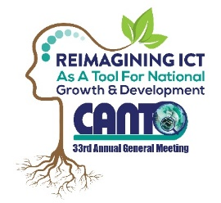 | 33rd Annual General Meeting  29^{th –} 31st January, 2017  Renaissance Hotel  Curacao

Human Resource Committee Meeting Agenda
Monday, 30th January 2017
Time: 2:30 pm – 4:00 pm

Chaired by: Linus Rogers,
Vice Chair: Christel Croes,

Agenda
- Opening

- Approval of Draft Agenda

- Status of DRM Workshop

- Status of HR Forum – CANTO 2017

Possible topics and speakers for event

- Any other Training Ideas

- Action Plan for 2017

- Any other Business

- Next Meeting

- Closing

