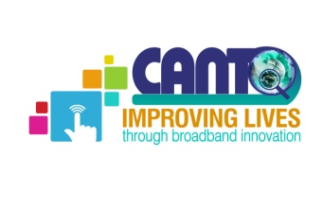 | 31st Annual General Meeting  Improving lives through Broadband Innovation  25th to 29th January, 2015  Torarica Hotel  Paramaribo, Suriname  Co-hosted by: TELESUR
Doc. 8
AGENDA

CANTO Regulations & Emerging Technologies Committee Meeting
Sunday 25th January, 2015
Time: 10.30am – 12.30pm

Chaired by: Delreo Newman, ATN, Guyana
Vice Chairman, Regulations & Emerging Technologies Committee

- Opening Remarks
- Approval of the Agenda
- Review Minutes of 31st October, 2014
- Status of Markets
- WRC 2015
- Procedure for Drafting Papers (information, discussion, policy, position papers)
- Plans for 2015
- Closing

Regulations and Emerging Technologies Committee Report

Chaired by: Melesia Sutherland-Campbell, LIME Jamaica; Vice Chair: Delreo Newman, ATNI Guyana
The Regulations and Emerging Technologies committee focused on the following in 2014:

- CANTO policy paper on Transparency of Regulators Budget
- Discussion paper on Over the Top Operators (OTTs)
- Incorporation of Broadband Incentive Investment in CARICOM Single ICT Document
- Proceedings for the first face to face meeting on CARICOM Single ICT Space
- Radio Frequency Management in the Americas
- Competition and Universal Service
- Regulation in the EU and the US - Should the Caribbean follow suit
- In 2015 the committee will provide input on:
  - WRC2015 and
  - the procedures and processes of documents (policy/information/discussion) produced by the committee for submission to the Board. Once the procedures have been approved by the Board, it will form the basis of all documents from all working committees of the Board.

