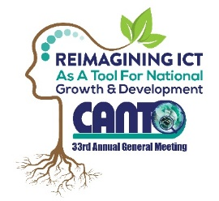 | 33rd Annual General Meeting  29^{th –} 31st January, 2017  Renaissance Hotel  Curacao

Marketing & Communications Committee Meeting Agenda
Monday, 30th January 2017
Time: 1:00 pm – 2:30 pm
Ball room B

Chaired by: Joseph Samuel
Vice Chair: Melissa Harris

Agenda
1. Approval of Draft Agenda
2. Action Status
3. Revenue Generating Activities
a. Silent Auction
b. Development of Award Ceremony
4. Competitions (Updates)
a. WTISD 2017 Video Competition
b. CODE 3.0 Hackathon
5. Website Updates
6. 33rd Annual Conference Trade Exhibition
7. Revenue Generating Initiatives
8. A.O.B
9. Closing
10. Date of Next Meeting

