Manuel – Canto Conference speech

[show cover slide during walk-in]

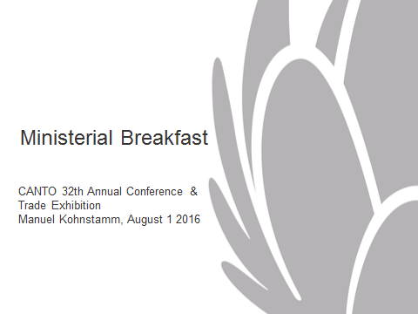

[show slide 2 at start of speech]
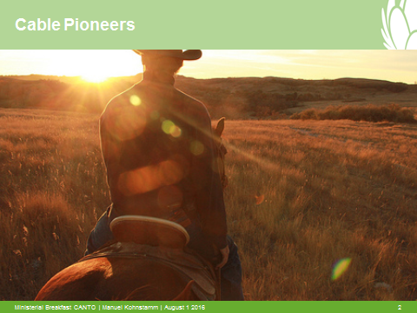

Honorable Ministers, Regulators, Ladies and Gentlemen,

It is a real honor to be here – in the Caribbean, a well-known region for Cable and Wireless, and increasingly so for Liberty Global. I am really excited about this opportunity to get to know more of your region, the people, the prospects and the plans for the future. As cable pioneers, we are curious by nature and always want to know what lies beyond the horizon. This is a region full of opportunities.

First of all, I would like to thank CANTO to give me the opportunity to speak to you at this occasion – the 32nd version of this high-level conference, gathering all stakeholders from governments, regulatory authorities and from the industry.

I greatly value this opportunity to exchange ideas and experiences and I am looking forward to meeting many of you in the coming days.

[show slide 3]
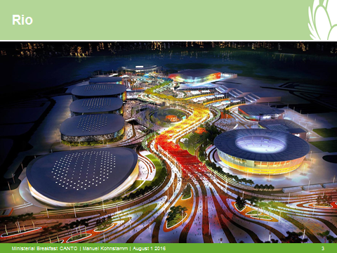

In just ten days’ time ten thousand athletes will spend 16 days competing in 42 sports in Rio de Janeiro. More than 300 medals will be handed out to the very best. A world class event with a worldwide audience.

Athletes from this part of the world will be among the top stars and I personally can’t wait to watch the Caribbean athletic stars.

Kirani James from Grenada, the Dominican Luguelin Santos, Jamaican Javon Francis and Trinidad &Tobago’s Machel Cedenio on the 400 metres. On javelin, I will watch out for T&T’s Keshorn Walcott. On the women’s side Shaunae Miller from the Bahamas has a good chance on the 400 metres and Jamaica’s champion on the100-metre hurdles Danielle Williams will be the one to beat.

And of course - when Usain Bolt gets to the start of the 100 and 200 metres, I will be simply glued to the screen. Usain is a major asset for the company I represent here – Liberty Global. He is the face of our advertising in the UK - Quite simply there is no one better to convey the speed and strength of our broadband network than this powerful sprint champion.

[show slide 4]
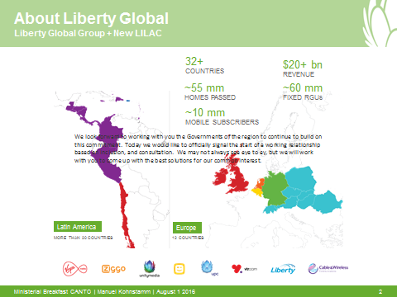

As you probably know, Liberty Global is the largest television and broadband company in the world. Our UK company Virgin Media is a big chunk of that. Before our acquisition of Cable and Wireless, we were present in 14 countries – 12 of them in Europe, the other 2 in Chile and Puorto Rico. So we are not new to the region.

With the acquisition of C&W, we are now in 32 countries and our networks pass the homes of 55 million households. We supply 60 million customers with fixed access to video services and to the internet. And from our revenue stream of 20 billion dollars per year we invest more than 20% in our networks – every year. Among others, we have committed to build 7 million new home connections in Europe in the next three years.

[show slide 5]
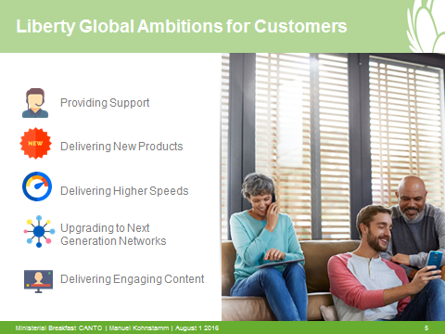

It is our mission to empower our customers to enjoy the benefits of the digital revolution. Our scale allows us to invest and innovate to make this possible.

In Europe, 28 million customers benefit from the world of connected entertainment that we have created with high-speed, high-quality networks, next-generation TV platforms, rich on-demand content and ubiquitous connectivity through superior WiFi -- Only a few months ago we have boosted our top speeds in Chile and Puerto Rico 5 times: from 20 to 100 MBS.

With C&W, we have strengthened our link to the Caribbean. The brands Flow, C&W business and C&W networks are serving more than 10 million customers in more than twenty countries with mobile, video, voice and broadband services.

[show slide 6]
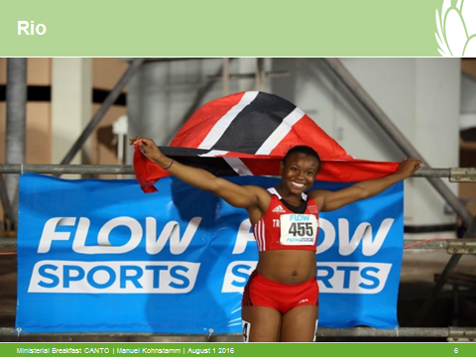

I am excited that C&W is the official broadcast partner of next week’s Olympic Games. They have invested heavily into developing dedicated televisions channels, on-line micro sites and even a Flow Olympic app – all aiming for audiences of more than 15 million people across the region. If you haven’t seen the Flow Rio 2016 App yet – do check it out to get a taste of how the games will literally be at your fingertips. This will be the most innovative and immersive sports programming experience yet – seen from your own geographical perspective – not the one from the big American networks or the BBC.

C&W has a rich heritage in the region, and along with the former Columbus Group, who in just 10 years established themselves as innovators, we will honor the legacy they have established.

At the same time, Liberty Global will bring the know-how and can-do entrepreneurial spirit that has made our company great. Today we are a big challenger of the incumbent telecommunications companies in Europe, giving consumers what they want: superior products and services for a reasonable price. From laying cables to creating clouds, our success has been built on a relentless determination to discover what’s next, challenge the status quo and break new ground.

The set of sound and stable policies that the European Union developed over the last decade has greatly contributed our ability to create these great benefits for our European consumers, who enjoy state of the art internet speed and quality.

[show slide 7]
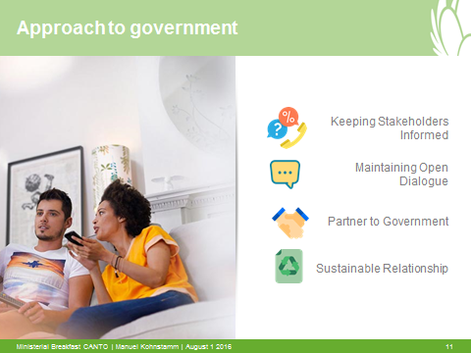

I realize that the markets in this region are structured differently. But I strongly believe C&W will be able to share in our experience. In Europe, our contributions to the framework of telecommunications policies are aimed at creating the best possible circumstances for the industry to flourish and for individuals and businesses to get the best from the digital economy. We look forward to working with you - the governments and regulators of the region to create a strong basis for the industry and its consumers. We believe in consultation, in close working relationships and frank exchange with those in the service of the public – our citizens, our consumers.

We recognize the qualities of our new Caribbean and Latin American colleagues. And nowhere is that more obvious than in the way you nurture your athletes.

Like Jaheel Hyde.

[show slide 8]
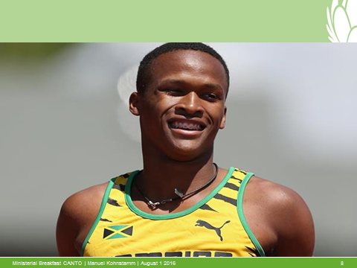

Just four years ago he scored a hattrick against Bermuda on behalf of Jamaica’s under 17 football team. Then he switched sport and a year later he got the GOLD in the 100 metres at the World Youth championships in the Ukraine. A year later he took Gold in the 400 metre hurdles in Oregon and he’s now heading for the Olympics.

In this industry we have much in common with such athletes. We have to constantly adapt, change tack, reinvent ourselves and show a ruthless determination to stay ahead of the pack. And just like in sports, we also bring people together.

Cable and Wireless has a stated mission of CONNECTING COMMUNITIES, TRANSFORMING LIVES. This is what we do.

Imagine a world without broadband, telephony or video. Digital connectivity transcends borders. In order to answer the irresistible desire of people to be connected with faster, better and more extensive digital experiences, we – the industry, legislators and regulators – have to transcend borders too.

Thank you very much.

[show slide 9]

+++

